Create a flume agent that streams data from Twitter and stores in the HDFS.

Twitter app is crated

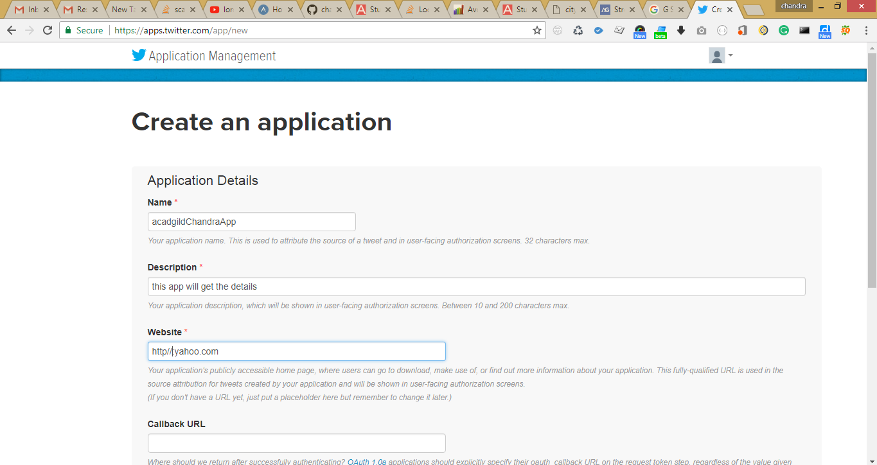

Keys and tokens are created in twitter app

Consumer Key

Eewx7wf3rErp2eb8IMcGieaNQ

Consumer Secret (API Secret)

2U6at0adaQe3A90kW8v2fBSFi2rQvzs4ywRffzm7Vxj2W7bI28

accesss token 2721003140-DHy6pcaeyVclzi61nGTFnUIvnOZNeFLvJDAeBEN

access token secret

4irz4M8FoqmMKXKg5grgr709PmiBNJSWERAEFZqyxiW0j

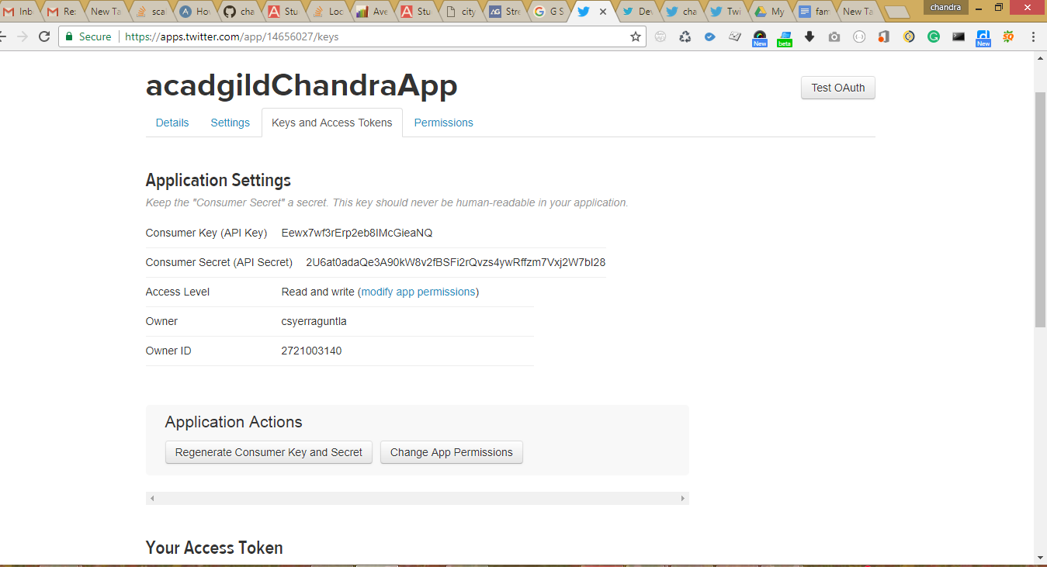

Flume installed and flume.conf is added to conf directory

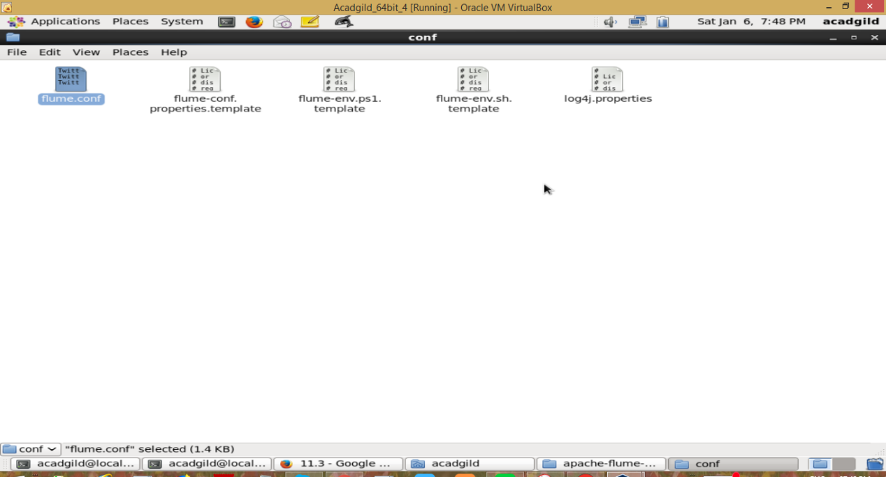

Flume.conf

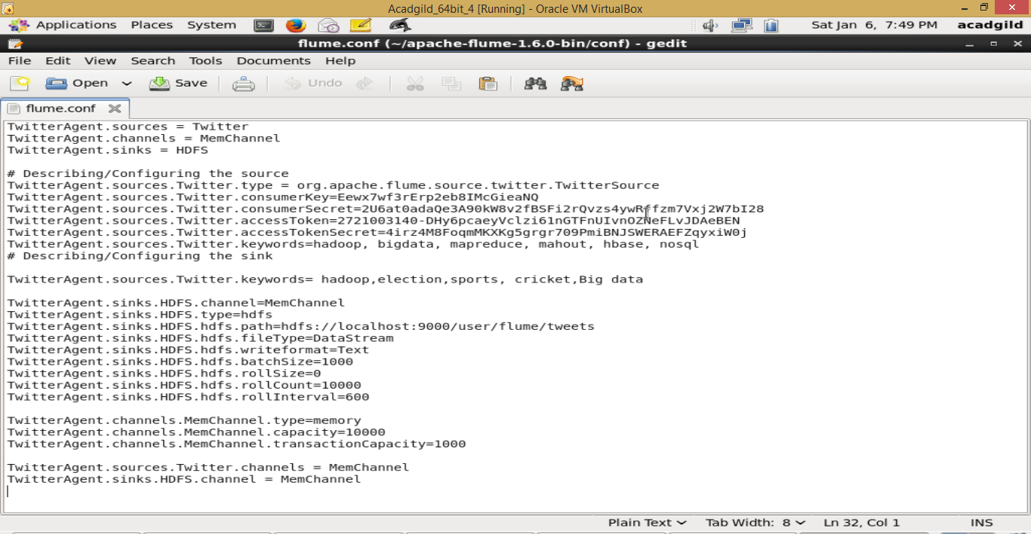

Modified the bashrc file

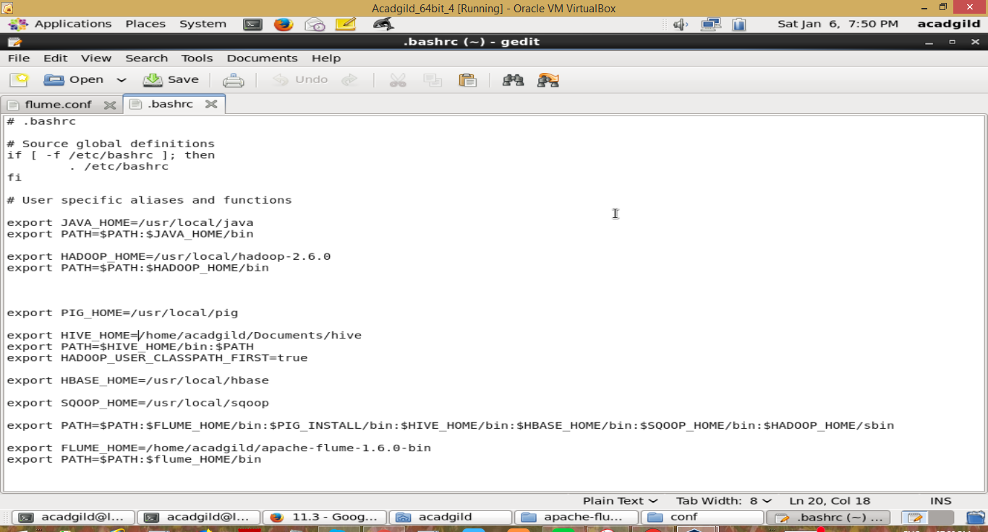

Hdfs twitts folder created by following commands

hdfs dfs -mkdir /user

hdfs dfs -mkdir /user/flume

hdfs dfs -mkdir /user/flume/tweets/

hdfs dfs -chmod 0777 /user/flume/tweets/

Executed the flume command

*flume-ng agent -n TwitterAgent -f /home/acadgild/apache-flume-1.6.0-bin/conf/flume.conf*

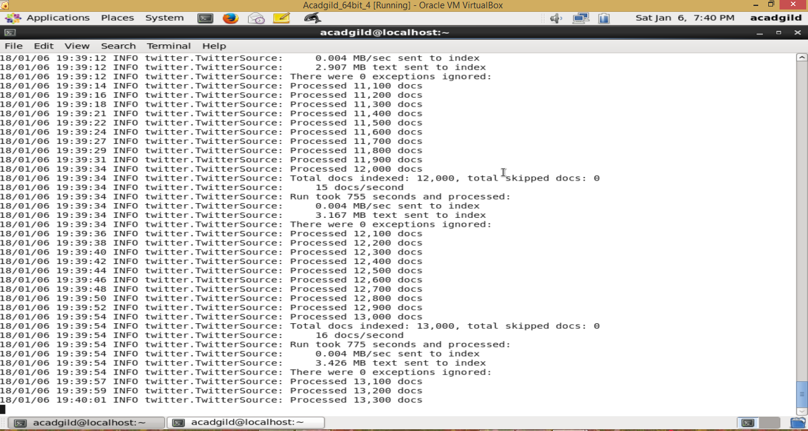

hdfs dfs -ls /user/flume/tweets/

hdfs dfs -cat /user/flume/tweets/FlumeData.1515247029384

Hdfs file created on /user/flume/tweets

